ID & Name:
150720823 – Nurullah Said Tüğmen

Pre-LAB Work
- 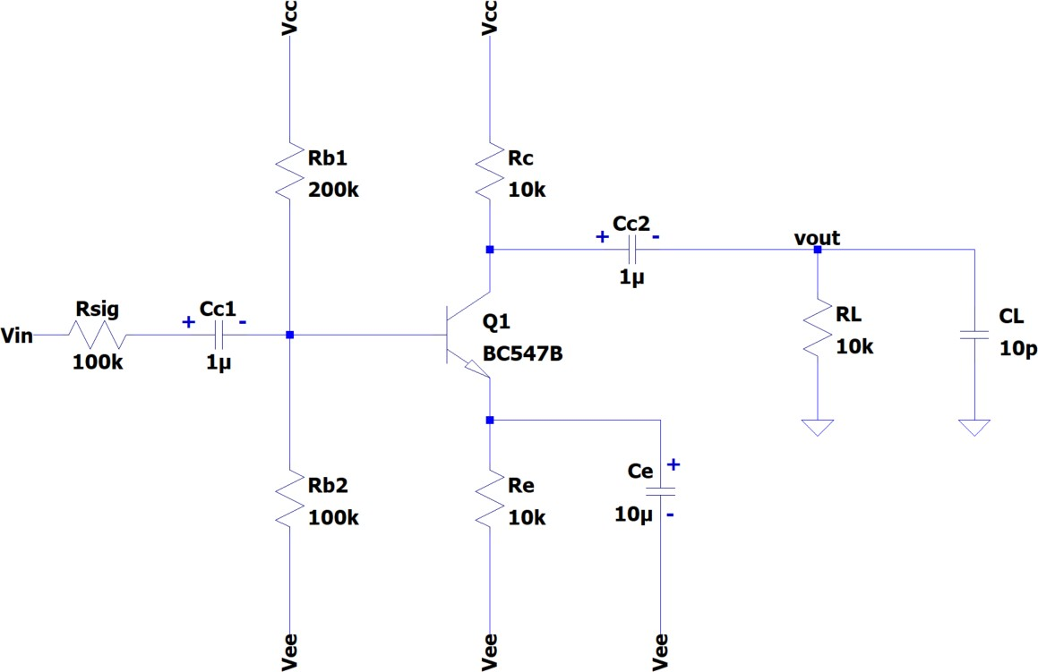For the circuits given in Fig. 1, calculate the low (fL) and high (fH) cut-off frequencies. Assume β=200, Cµ=3pF, Cπ=15pF. (Vcc=15V and Vee=-15V)

Figure 1

Answer:
Answer: F low = 105,7 (Hz)
F high = 88K (Hz)

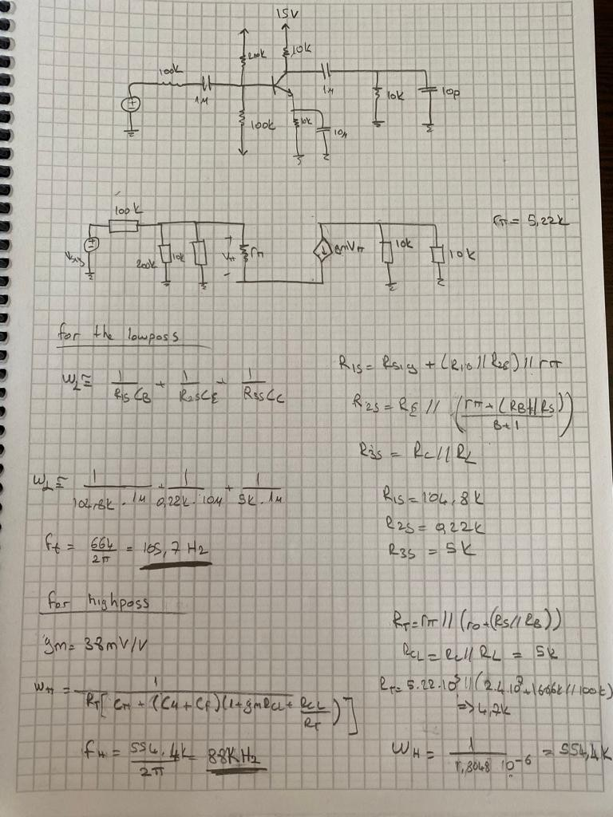

- Simulate the circuit in Fig. 1 with SPICE. Let Vcc=15V and Vee=-15V. Conduct an AC analysis using the following spice command and plot the amplitude of the frequency response. Indicate the low (fL) and high (fH) cut-off frequencies.

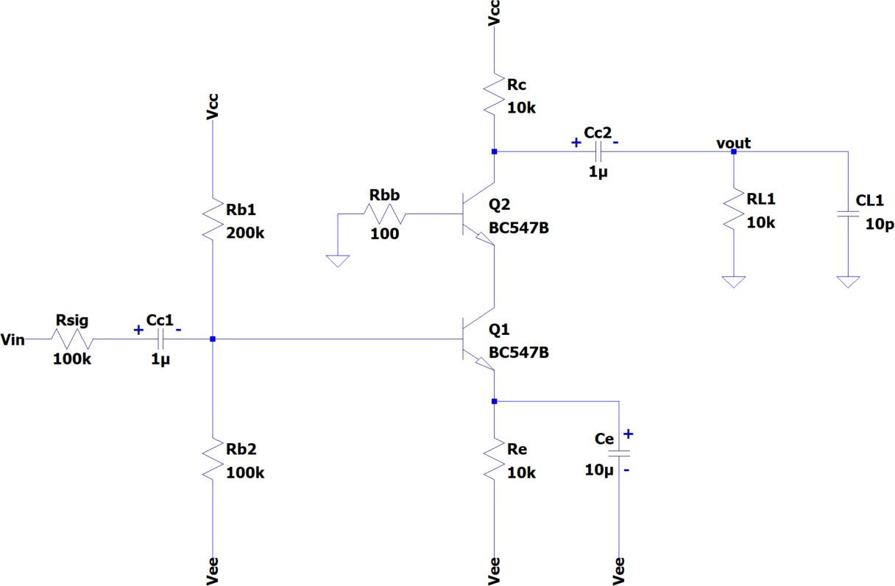.ac dec 10 1 10e6


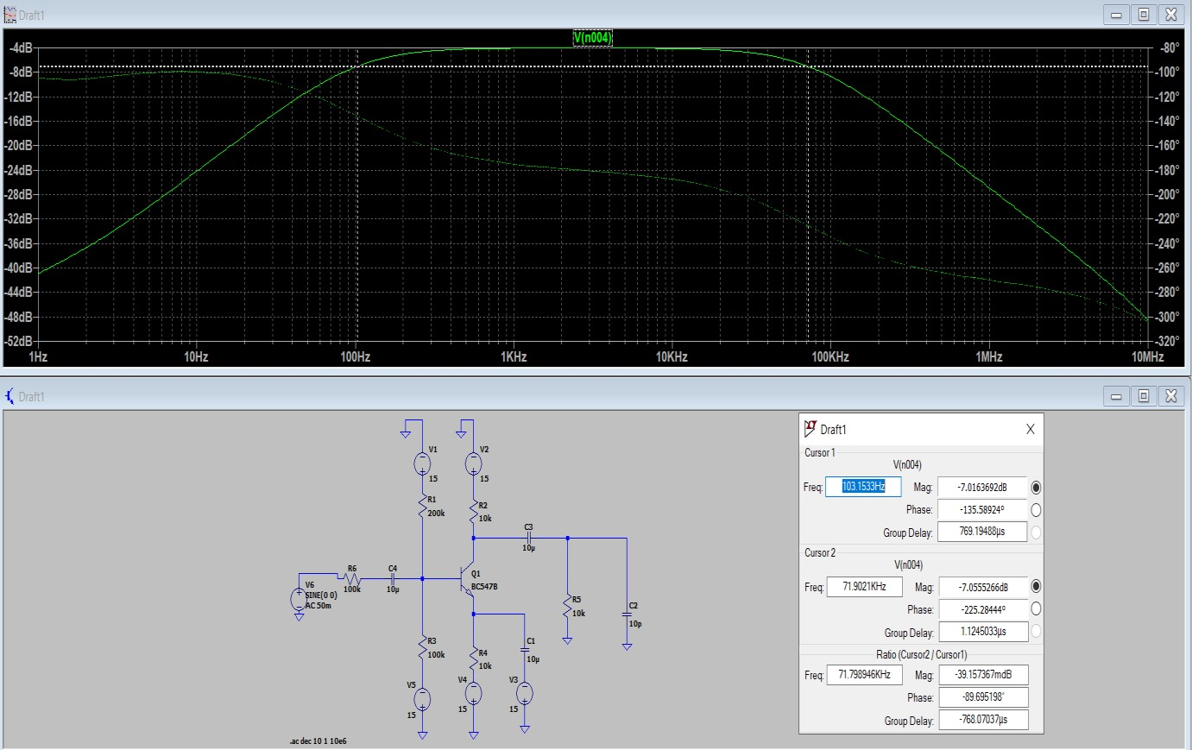

- For the circuits given in Fig. 2, calculate the low (fL) and high (fH) cut-off frequencies. Assume β=200, Cµ=3pF, Cπ=15pF. (Vcc=15V and Vee=-15V)
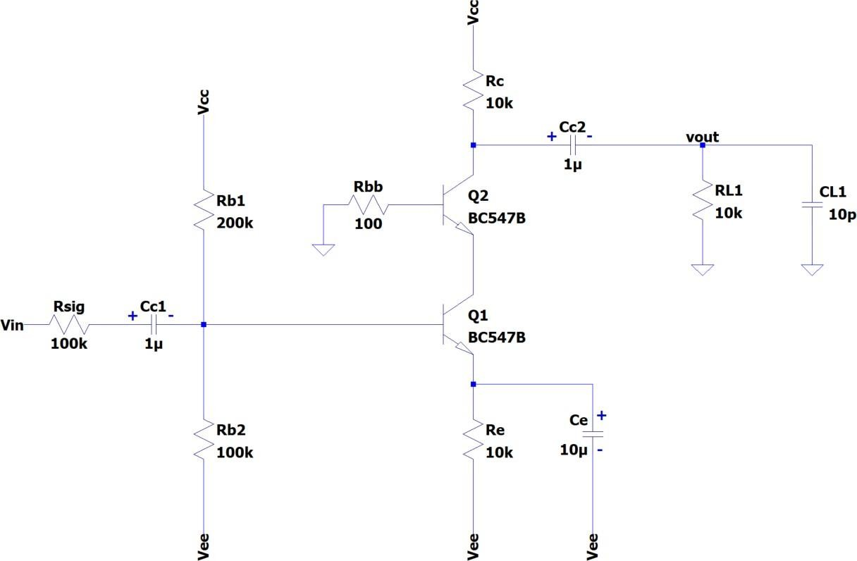

Figure 2

Answer: Answer: F low = 100 (Hz)
F high = 340K (Hz)

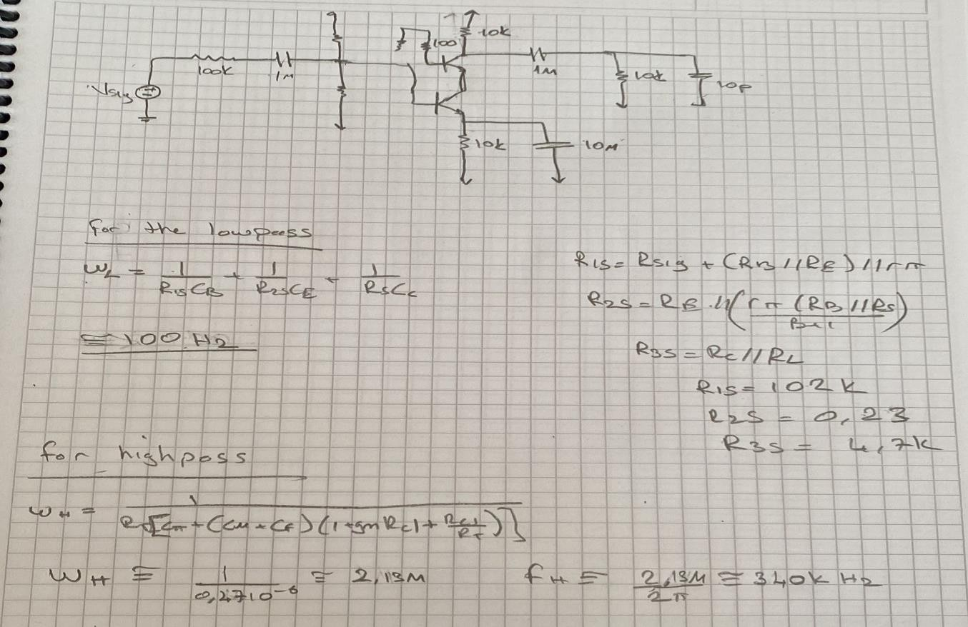
- Simulate the circuit in Fig. 2 with SPICE. Let Vcc=15V and Vee=-15V. Conduct an AC analysis and plot the amplitude of the frequency response. Indicate the low (fL) and high (fH) cut-off frequencies.
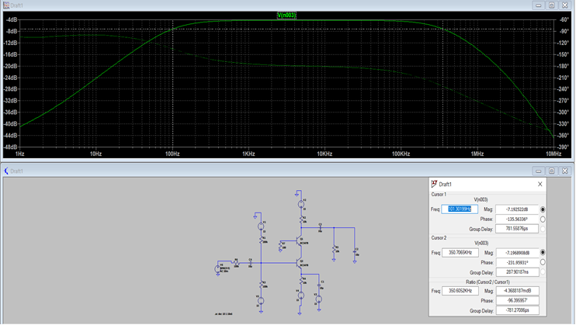


Equipment/Component List
Table 1: Equipment/Component List

Equipment/Component | Model/Value | Count
Breadboard | - | 1
Resistor | 100Ω | 1
Resistor | 10kΩ | 3
Resistor | 100kΩ | 2
Resistor | 200kΩ | 1
Capacitor | 10pF | 1
Capacitor | 1µF | 2
Capacitor | 10µF | 1
BJT (npn) | BC547 | 2
Multi-meter | - | 1
Function Generator | - | 1
Oscilloscope | - | 1
Voltage Source | 15V, -15V | 1
Probes & Cables | - | -

Experiment Procedure
- Adjust Vcc to 15V and Vee to -15V. You will also need the ground connection. Do not connect the supplies.
- Set-up the circuit in Fig. 1. Be very careful while connecting the capacitor. The +/- pins must be connected as shown in the Fig. 1.
- Connect the ground and then Vee and Vcc.
- Apply sine waves of 10Hz, 100Hz, 1kHz, 10kHz, 100kHz, 1MHz, 10MHz with amplitudes of 50mV to Vin.
- Also find the 3-dB cut-off frequencies.
- Plot the gain in dB as a function of the frequency. Indicate the low (fL) and high (fH) cut-off frequencies.

Page
Answer:

- Power down and disassemble the circuit.
- Set-up the circuit in Fig. 2. Be very careful while connecting the capacitor. The +/- pins must be connected as shown in the Fig. 2.
- Connect the ground and then Vee and Vcc. Power up your circuit.
- Apply sine waves of 10Hz, 100Hz, 1kHz, 10kHz, 100kHz, 1MHz, 10MHz with amplitudes of 50mV to Vin.
- Also find the 3-dB cut-off frequencies.
- Plot the gain in dB as a function of the frequency. Indicate the low (fL) and high (fH) cut-off frequencies.
- Compare the calculated (step 1, 3), simulated (step 2, 4) and measured (step 10, 16) responses.

